Shanghai QA Virtual Lab User Guide

Revision Number | Date | Author | Summary/Comments
1.0 | Jan 22, 2021 | Neil Zhang | Documentation creation
1.1 | Apr 15, 2021 | Neil Zhang | Documentation modified

Shanghai QA Virtual Lab User Guide 1
Introduction 4
Design Overview 4
Hardware Components 5
Switch structure 5
VMware Servers 5
DUT Pool 5
Console Manager 5
Power Controller 5
Dialup Router 5
QA Lab Core Switch 5
Virtual Lab Concept 6
Accessing Virtual Lab 6
Security 6
Web Management Interface 6
VM Pool 7
DUT Pool 8
VLANs 9
• Administrative VLANs (3) 9
• Private VLANs (10): 9
• IXIA VLANs (8): 9
• To US VLANs (1): 9
Top Control Panel 11
Refresh Button 11
VM MGMT. 11
DUT Mgmt. 11
PC Mgmt. 11
Devices Search 12
VLAN Search 12
Public Testbed 13
Enhancement 13
Sidebar Function Details 13
Device Summary 13
Dashboard 13
LAB Devices 14
Cube Devices 15
Wireless PC Control 16
Ixia Control 16
My Devices 17
LAB Devices Summary 17
Firewall 18
My VMs 22
ESXi List 22
Auto Tools 23
Firewall Settings 23
Public Testbed 24
Connection Tool 24
Switch Config 25
Reset Setting 25
VLAB MGMT 26
User Setting 26
Device Setting 26
VM Setting 27
Ticket(Feedback) 28
VLAB LOG 29
Long Tasks Log 29
Login Log 30
Operated Log 31
User Guidelines 31
Must to do (First Login) 31
Borrow/Return DUT 33
Firewall & SonicPoint port config 35
Tips & Debug 38
Err-disabled. 38
DUT Power Failure. 38
LAG On. 38
Pre-configured Failed. 39
Transfer Public Pool. 39
Response error. 40
Switch line protocol down. 41

Introduction
This user guide seeks to provide a comprehensive documentation on how to get started with the Sonicwall Shanghai QA Virtual Lab .

Design Overview
The design of the Shanghai QA focuses on the setting up of layer-2/3 connectivity between a VM and a DUT through the use of a VLAN-capable switching fabric. The following diagram shows the design layout:
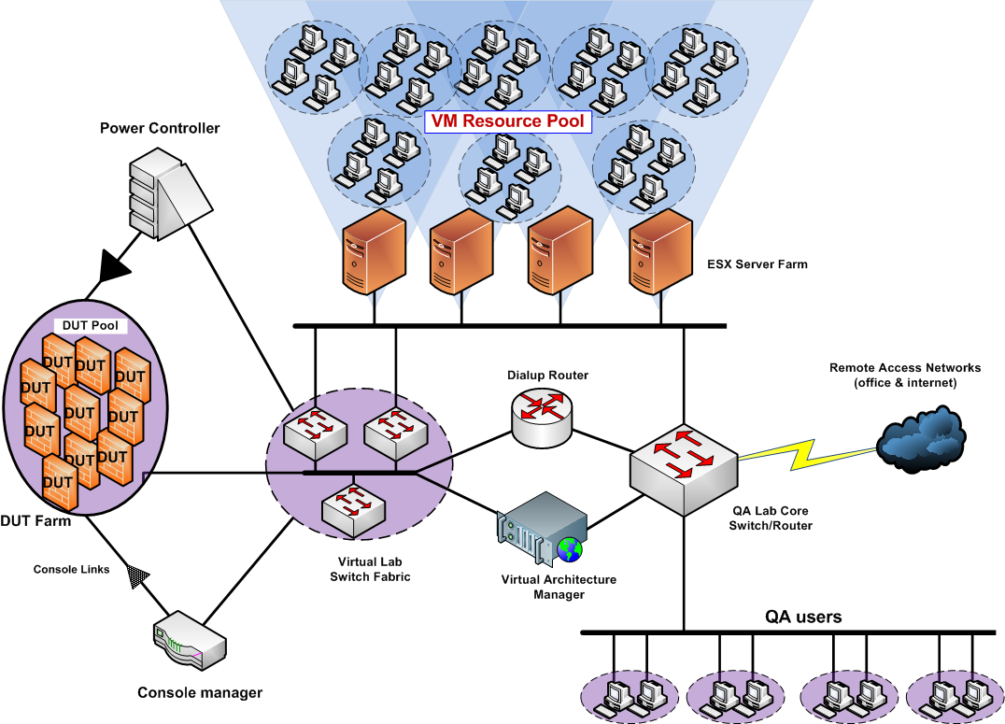

Hardware Components

Switch structure
The switch structure provides the backbone of the entire infrastructure. DUTs , SonicPoints , and VM servers are all connected the switch structure.
The switch structure uses VLANs to isolate traffic from different users at the OSI layer2, thus providing a robust , scalable and secure infrastructure.

VMware Servers
VMware ESX servers host the VMs for each user. Each user’s VM pool are grouped together in a Resource Pool. The resource pools (RPs) could be used as VM QoS tools to limit resource oversubscription by a particular user.
Because of Vcenter version’s limited, the user can only use the VM on Browner such as Firefox, Chorme.

DUT Pool
Each DUT is statically assigned to a particular user. But there’s a feature that has been added to provide the capability of exchanging DUTs among users. (See DUT Exchange)> Only the administrator can add DUTs into the DUT pool.
When DUT is added into the My Devices , up to a maximum of five (5) of its network interfaces are connected to the switch fabric and these port mappings are noted. With these mappings, we’d be able to configure the respective switch ports and DUT interfaces accordingly. In case , the console port is connected to the a port on the console server (and noted).

Console Manager
The console manager provides direct console access to each DUT or SonicPoint console. Thus , if there’s a crash , it will still be possible to grab the console output from the firewall.

Power Controller
The power controllers provide a means of remotely power cycling DUTs and SonicPoints. Power controllers are not available at the moment , so DUTs must be power-cycled manually by the administrator if the need arises.

Dialup Router
The dialup router provisions for various network services such as DHCP(v6) , PPTP , L2TP , PPPoE etc. The default IP(v6) addresses of the VLAN interfaces are as follows:
10.8.X.254
2001:470:80b7:X::/64

Where X is the VLAN ID (PPTP and L2TP will get the 5.0 subnet)

QA Lab Core Switch
Provides layer-3 connectivity to the rest of the corporate network and Internet.

Virtual Lab Concept
The concept is simple: place a VM interface and a DUT interface on the same VLAN and a connection is established.
With exception of configuring a DUT interface as a trunk port, the rest of the configuration involves placing an interface (whether it’s a VM or SonicPoint or DUT interface) to a particular VLAN to establish layer-2 connectivity.

Accessing Virtual Lab

Servers’ IP addresses
Service | IP Address | Comments
Web management | 10.103.2.123  10.103.2.125 | Web configuration.
Authentication manager | 10.103.2.39 | Active-Directory user database
Wireless PC | 10.8.139.211-219 | Desktop computer
ESX Server | 10.8.2.x | - Windows server farm  - Linux server farm  - Users’ VMs
Console Server1 | 10.8.0.x | - Default username/password for console access : qa/qa

Security
The Virtual Lab infrastructure is as secure as the network on which it runs. The user database used for authentication is independent of the corporate login , so compromise of a user’s virtual lab login credentials will NOT affect their corporate account. Users are therefore encouraged to keep these credential separate and distinct from each other.

Web Management Interface
Below is a sample layout of the web management interface:

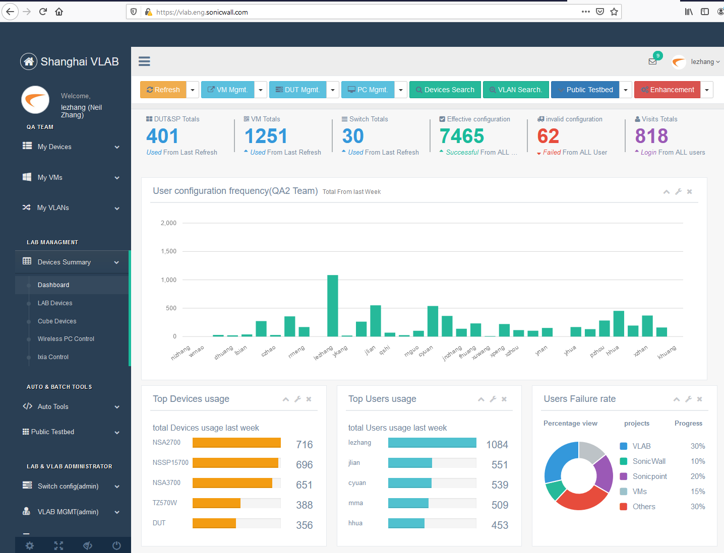

VM Pool
The “VM Pool” section displays the list of virtual machines that have been assigned to the user. Clicking on the each VM will display its settings, as shown below :
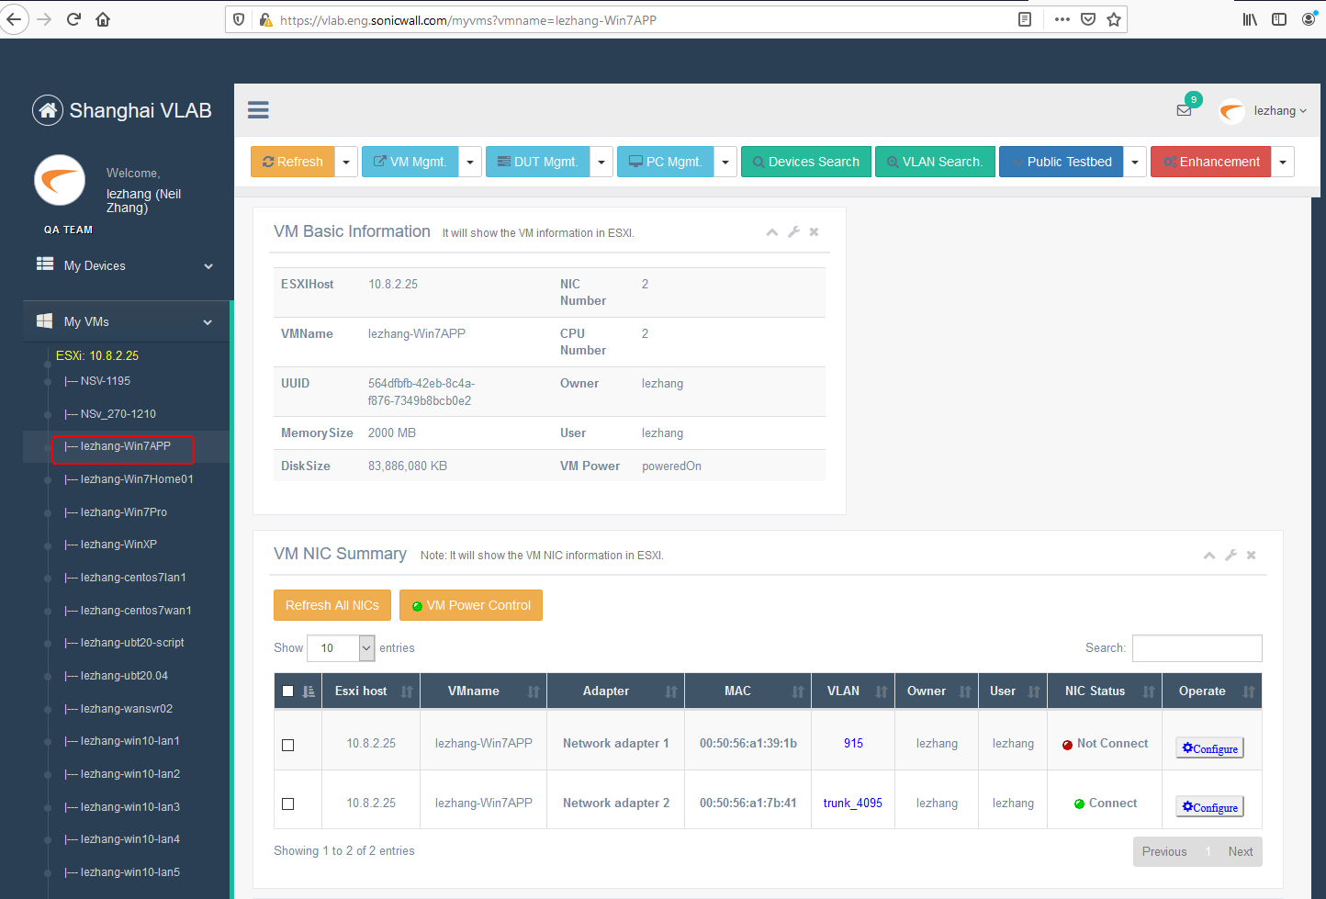

DUT Pool
This shows the list of DUTs currently assigned to the user. Note that , at the moment of this document was being written , DUTs must be manually assigned to each user by the administrator.
Clicking on a DUT would display its properties, as show below:
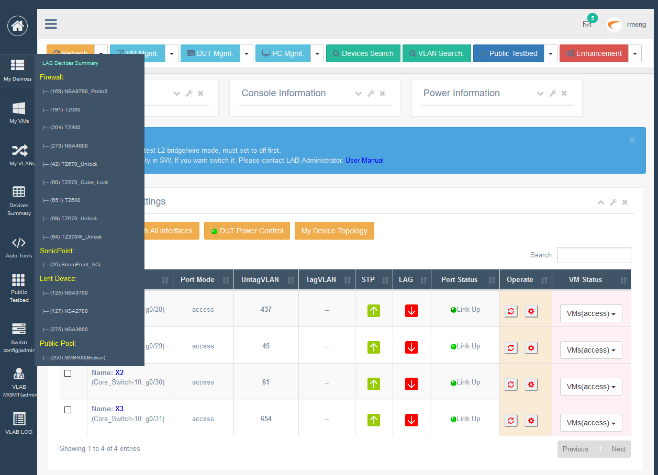

VLANs
This section shows the list of VLANs currently assigned to each user. Like DUTs, VLANs are administratively assigned and may not be modified by the user. There are 2 types of VLANs used :
- Administrative VLANs (3) : These are VLANs with Layer 3 (IP/IPv6) features. They are used to provide remote network access to the Virtual infrastructure resources. The IP addresses of the admin VLANs are routable throughout the company network and may also be used to access the Internet.
- Private VLANs (10): These are VLANs that may only be used create user topologies and they do not have corresponding layer 3 features. It’s recommended that when testing, the LAN zone & DMZ (and other “internal” zones) be placed in these VLANs while networks that require routing and/or external/remote access be placed in Admin VLANs.
- IXIA VLANs (8): These are VLANs that may only be used IXIA network that when testing. Those VLANs do not support Broadcast packets between Device to VMs.
- To US VLANs (1): These are VLANs that may only be transferred to US Network via S2S, Valid pool range: (TBD)

With 13 VLANs , this would enable the user to create complex topologies to match their testing goals.
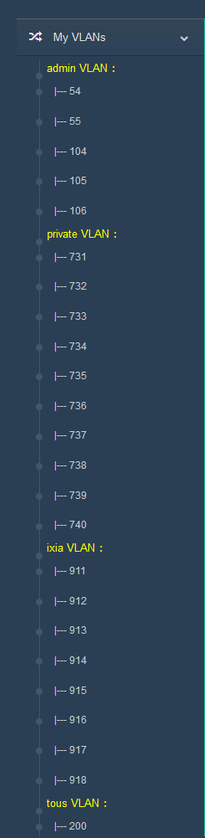

Top Control Panel
This section contains a list of features that can be modified for VMs, DUTs etc.
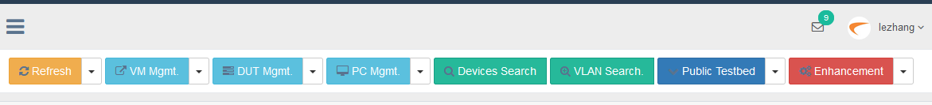

Refresh Button
This button provides a function for the user to update the DB Info.
Functions provided include:
- Refresh Sonicwall&SP
- Refresh VMs
- Refresh VLANs
- Refresh Dashboard
****Important****: below Refresh only Update info from DB, If you want see the real time data via Vcenter, Please press Sync ALL VMs Info From Vcenter and Manual Refresh VMs again.

VM MGMT.
This button provides a function for the user to config the VM.
Functions provided include:
- Change Name
- Power Control
- PortGroup Control
****Important****: If you add the VLAN to ESXI using the PortGroup Control, Please only add yourself VLAN Range.

DUT Mgmt.
This button provides a function for the user to config the Firewall and SonicPoint.
Functions provided include:
- FireWall MGMT
- SonicPoint MGMT

PC Mgmt.
This button provides a function for the user to order the Wireless PC and IXIA.
Functions provided include:
- Wireless PC
- Ixia

Devices Search
This button provides a function for the user to search the Firewall, SonicPoint and VMs.
****Important****: The Keyword supports part or full name input, the search will show all partial matching result.
For example:
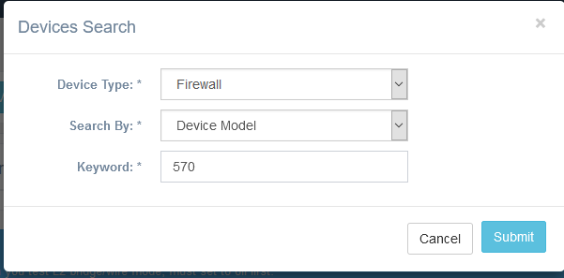
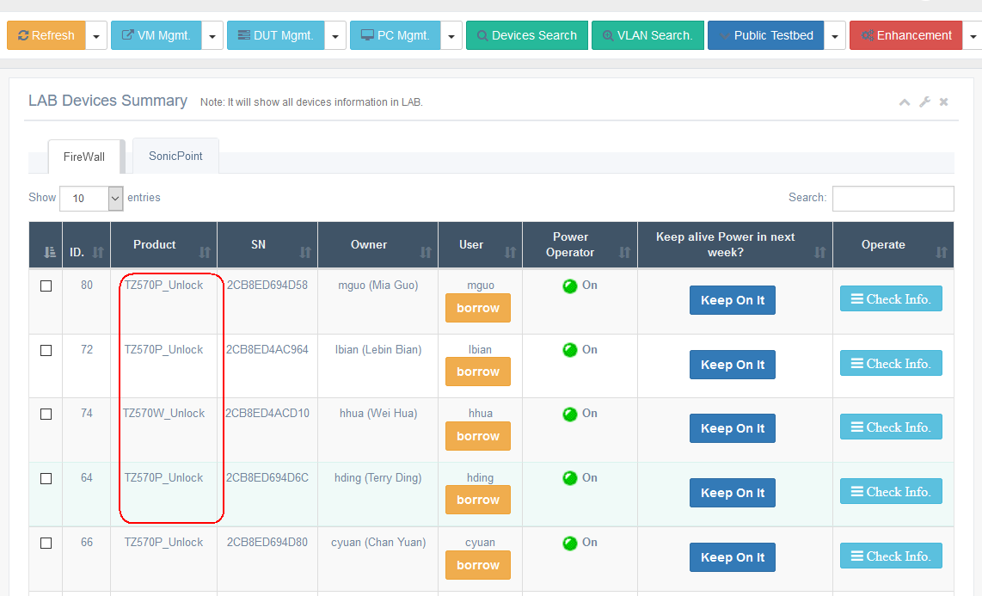

VLAN Search
This button provides a function for the user to search the Device, VM.
****Important****: Only support input single VLAN, the pool range is 2-4095. VLAN 4095 is Trunk port.
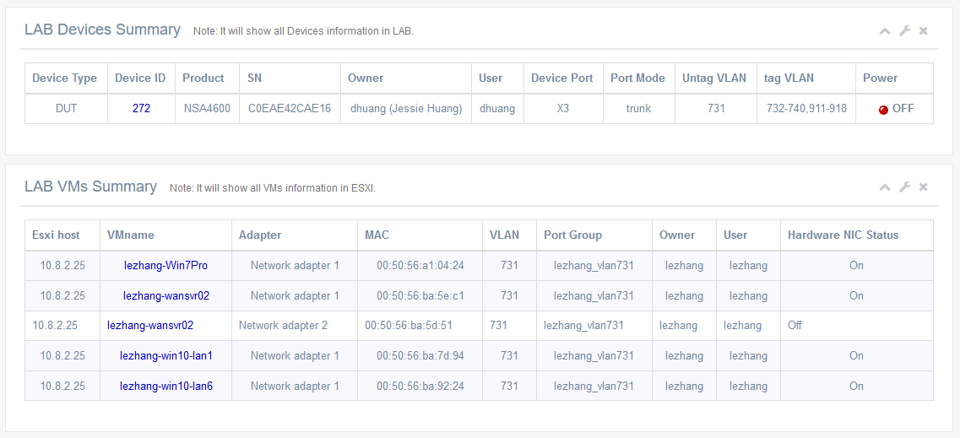

Public Testbed
This button provides a function for the user to use the common Testbed.
Functions provided include:
- Connection Tool
Provides a Connection Tools for Traffic test.

Enhancement
Some useful links about QA test

Sidebar Function Details

Device Summary

Dashboard
This page provides a function for show all user’s data total.
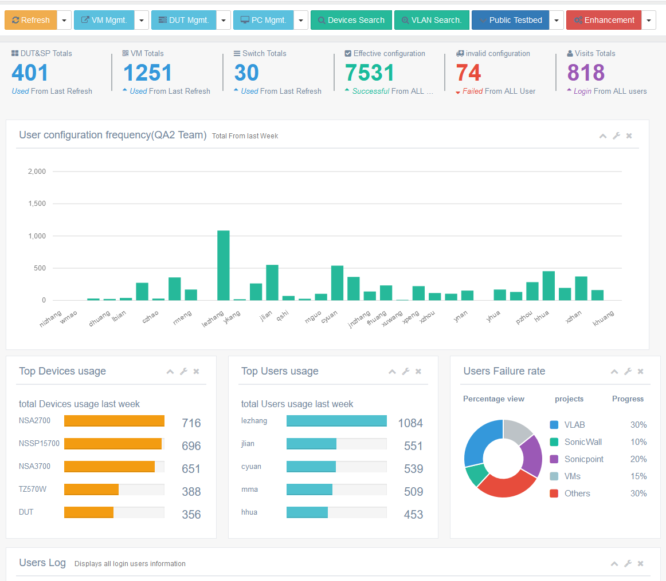

LAB Devices
This page provides a function for show all user’s FireWall and SonicPonit on LAB.
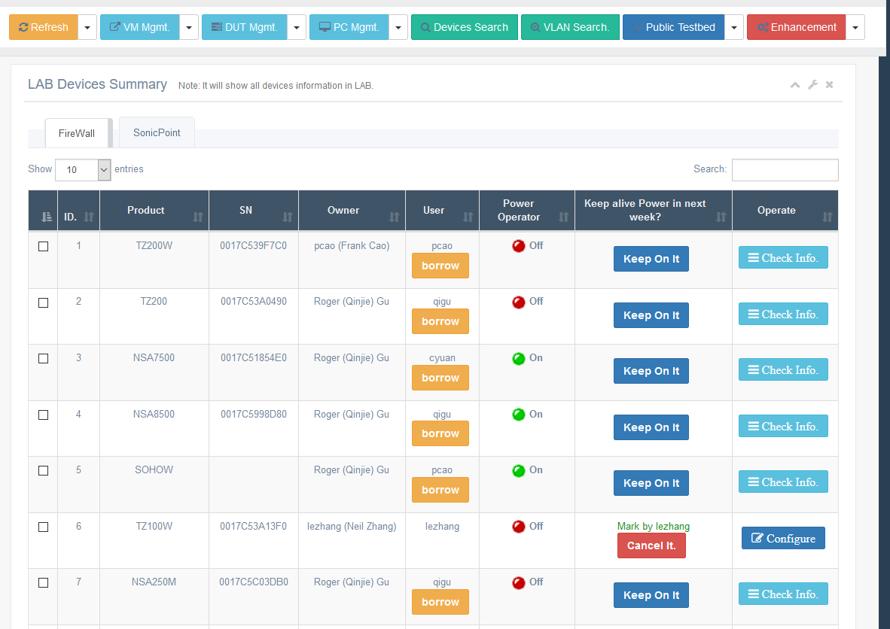
In this page, you can find a DUT and Borrow it. And yet check the basic information.
- Borrow Before want borrow the DUT, please ask user’s permission first. When you borrowed it, the current page will redirect to long task log page, [lease waiting until showing the log named Finished Initial All Ports, you can use it normally.
- Keep alive button Manage DUT power status. When you mark it, the DUT will power on in next week. If not the DUT will power down in schedule time. It usually turns off the power automatically at 8 pm Friday.

Cube Devices
This page provides a function for show all user’s FireWall and SonicPonit on Cube.
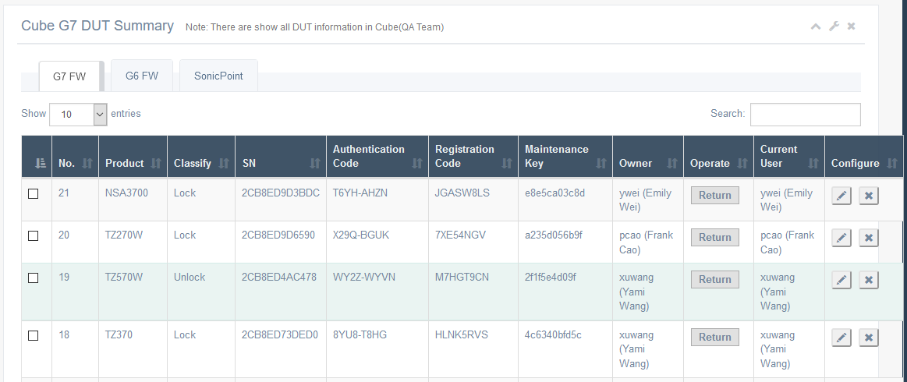

This page will show all devices in cube. Device only support update information, include add/modify/remove, And transfer function.

Wireless PC Control
This page provides a function for order the wireless PC
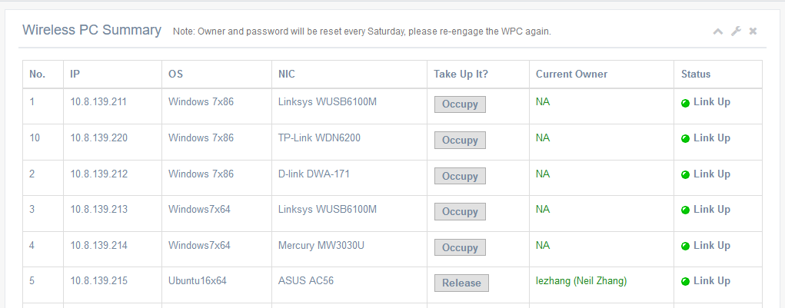

If you occupied a PC, an email include login info will send to the user. Please release the PC in this page timely.

Ixia Control
This page provides a function for order the Ixia.
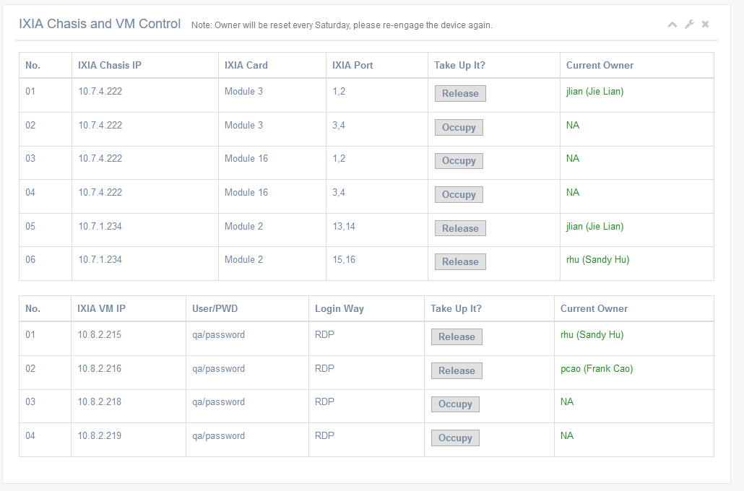
If you occupied an ixia port, please use settled VM to control the Ixia and release the Port in this page timely.

My Devices

LAB Devices Summary
This page will show user’s VLANs for devices which port power is on.

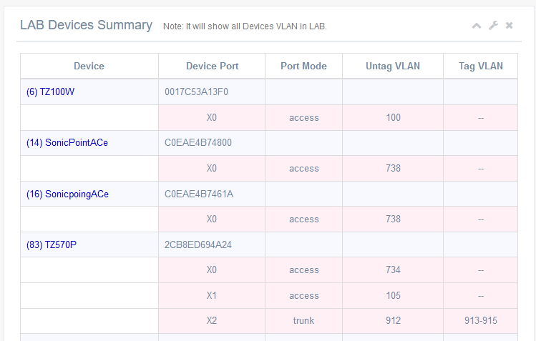

Firewall
This device list will show all DUT that belong to current user in LAB.
Include 4 types:
- Firewall the firewall used by current user.
- SonicPoint the SonicPoint used by Current user.
- Lent Device the DUT owned by current user but used by other.
- Public Pool the DUT is public by all users. Anyone can config it.

Functions provided include:
- Device Information show basic/console/power information in LAB
- Port Settings config switch port
- Switch Console show the switch configure result

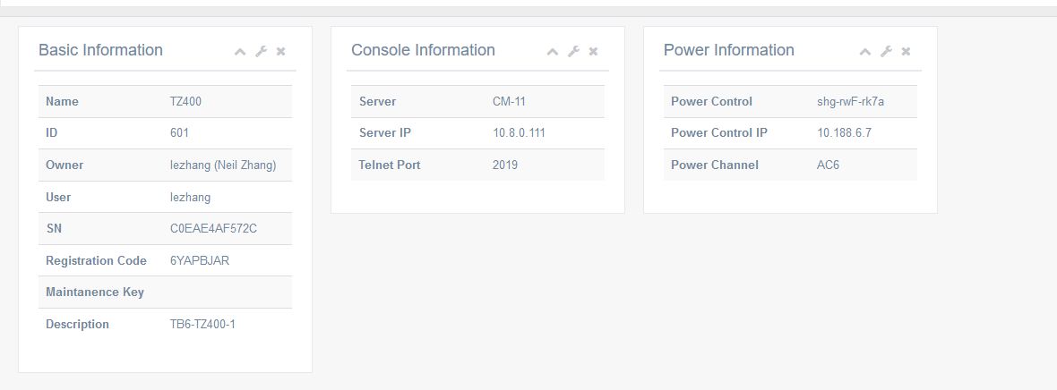
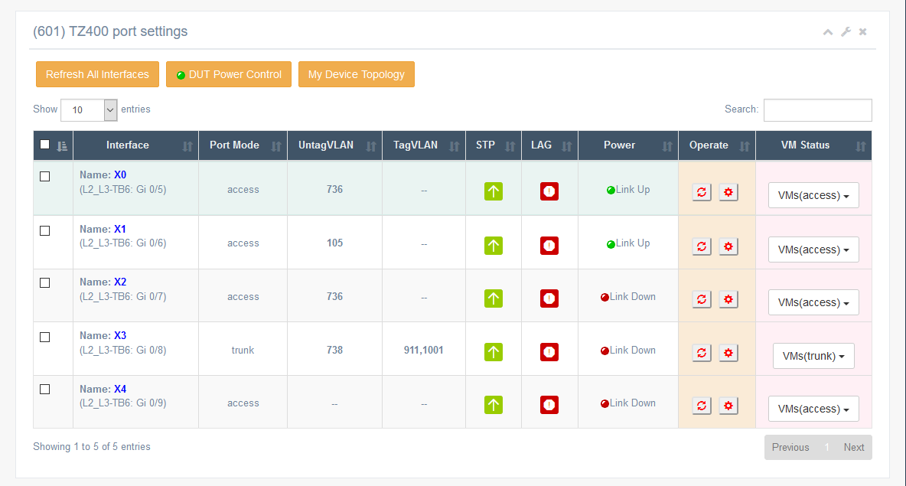
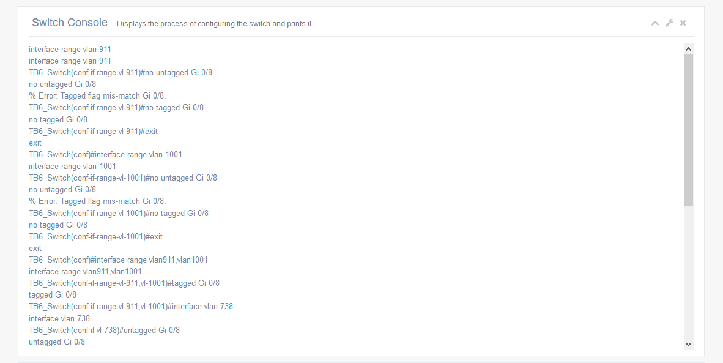
For Port Settings
Global settings
- Refresh All Interfaces It will refresh all switch ports information in currently.
- DUT Power Control It will power on/off/reboot/refresh the device’s power.
- My Device Topology It will show the device ports topology base on Valid VLAN and Link UP.
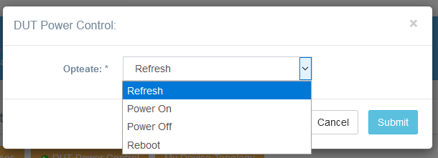
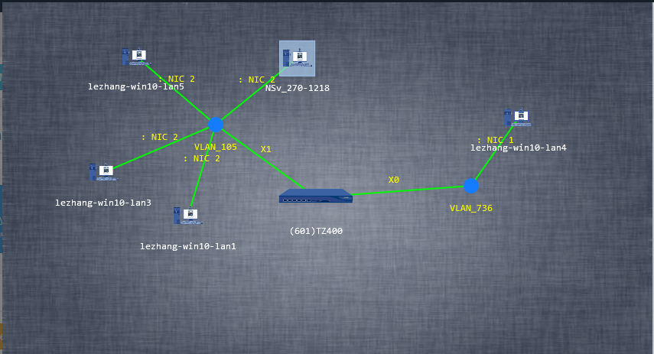
Single Port Setting
- Operate Refresh It will refresh the port information from switch port.
- Operate Config It will modify the port information to switch.
- VM Setting It will modify the VM NIC’s VLAN that same with device port.
****Important****:
For operate settings, It’s only support the device is Power On and the LAG is off.
If the device is power off, Please on it in DUT Power Control.
If the LAG function is On, Please contact LAB Administrator to manually change the SW port.
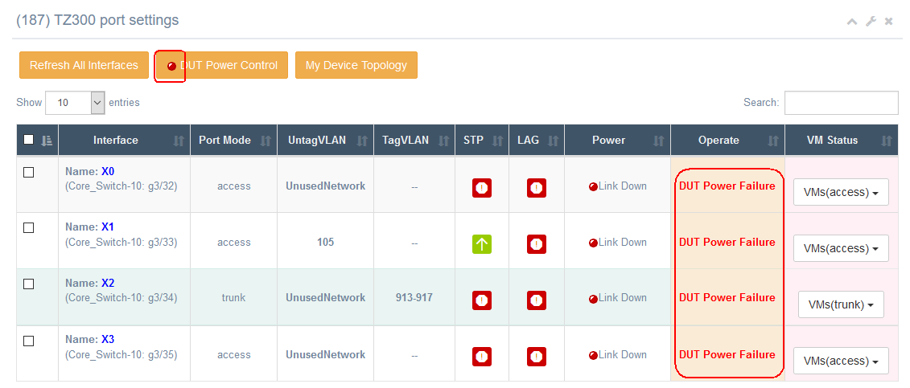
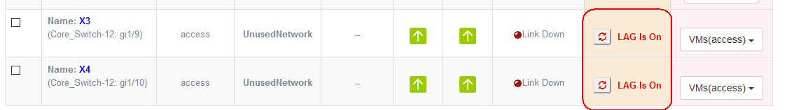
For VM Status list, It will list the same VLAN with device Port. You can change the VLAN in the pop-up window.
About trunk VLAN for VM, it will show Trunk_4095
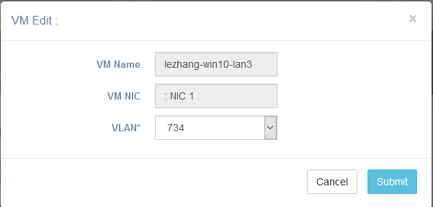
For Switch Console, It will show the configuration procedure in SW’s console while refresh or config the device port in Operate.
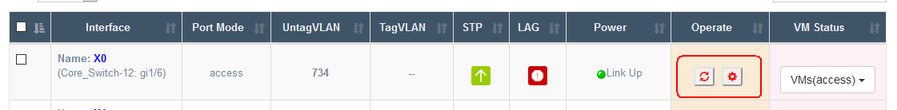
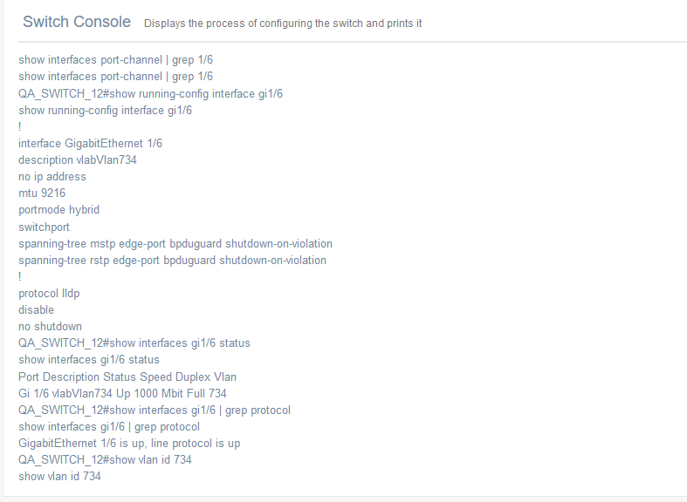

My VMs

ESXi List
This page will show user’s VMs in the Vcenter named his domain account.
A VM Basic Information
It will show the VM import info in page.
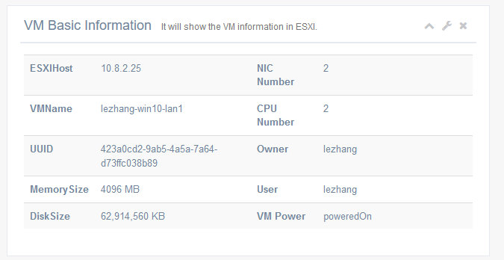
A VM NIC Summary
It will show the VM NIC’s information in ESXi
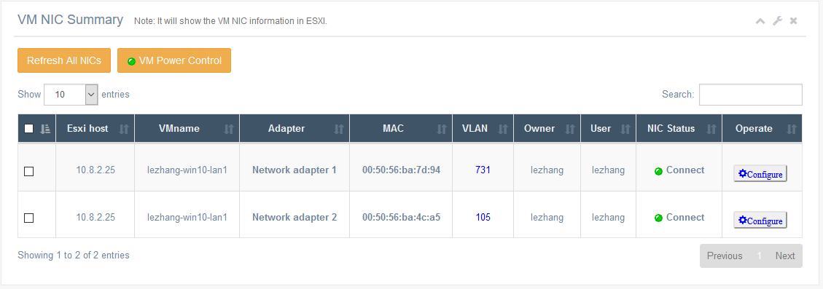
For Configure Function
It’s support config NIC’s VLAN and Power Status.
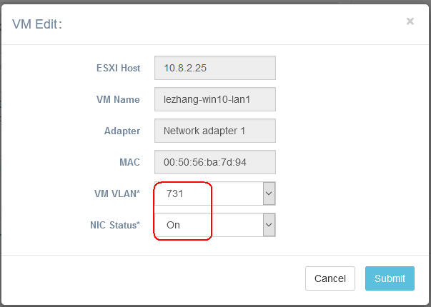

Auto Tools

Firewall Settings
It’s support config the G7 and G6 Firewall automation via CLI, include local user/local group/address object/address group/VPN/NET/Route/NDDP/SSL Server.
****Important****:
- must manually enable SSH and ping in FW WAN Interface, otherwise the script will do not access the Firewall.
- Do not support AWS, Azure.
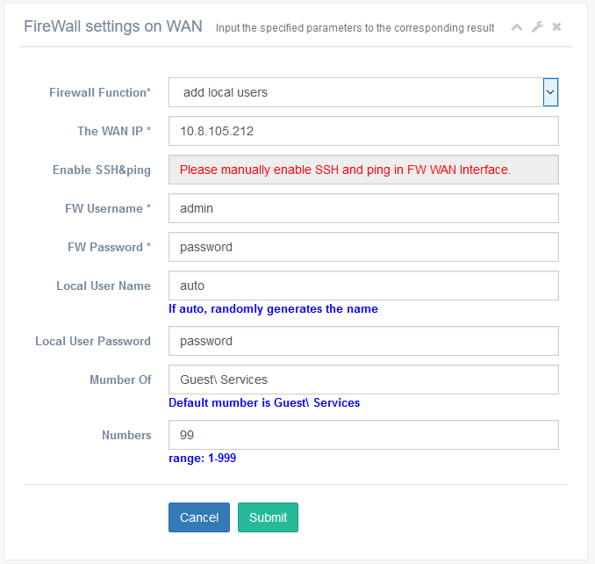

Public Testbed

Connection Tool
This tool simulates real network traffic, support http/https/ftp/ftps，have a high rate for IPv4 and IPv6.
If you want to use it. Please take up it and bind your private VLAN to Device LAN/DMZ zone. And make sure the traffic will pass to LAB Network(10.8.104.239) from LAN/DMZ to WAN.
The operate detail please check the user guide in current page.
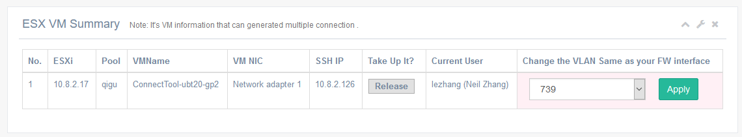

Switch Config

Reset Setting
It’s debug page while the SW port configure do not support the VLAB control.
It will reset all configure in the switch port in order to VLAB controlled.

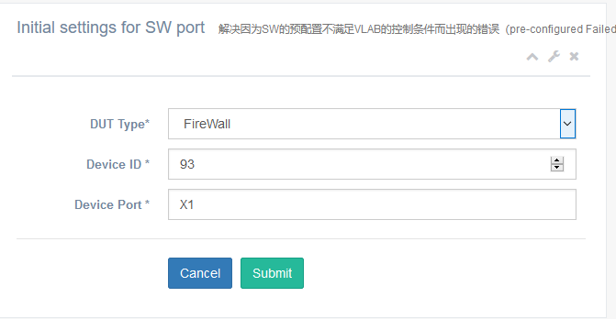
When you are config a device port and get a Pre-configured Failed result, Please use this page initial port setting.

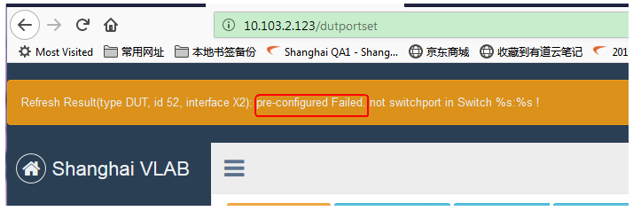

VLAB MGMT

User Setting
User Account operate page. It’s support add/modify/delete/search user in VLAB.
But it’s only OPERATE by Administrator.
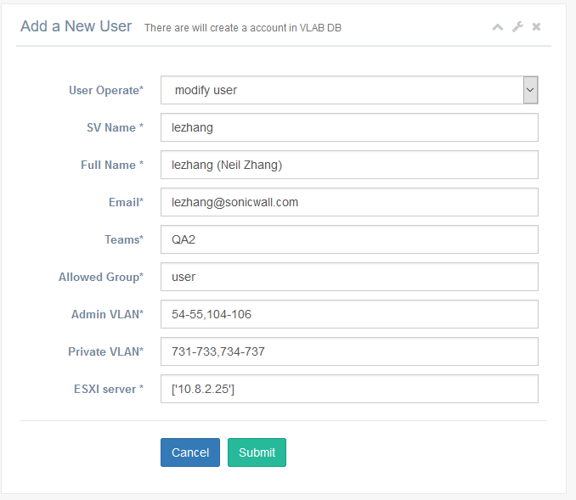

Device Setting
Device operate page. It’s support add/modify/delete/search the Device in VLAB.
But it’s only OPERATE by Administrator.
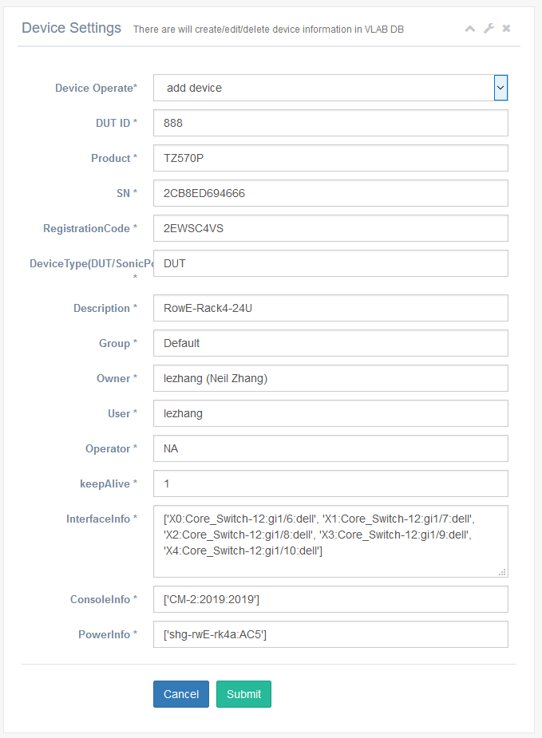

VM Setting
The page is support get/add/delete the port group in Esxi. It is available to All users.
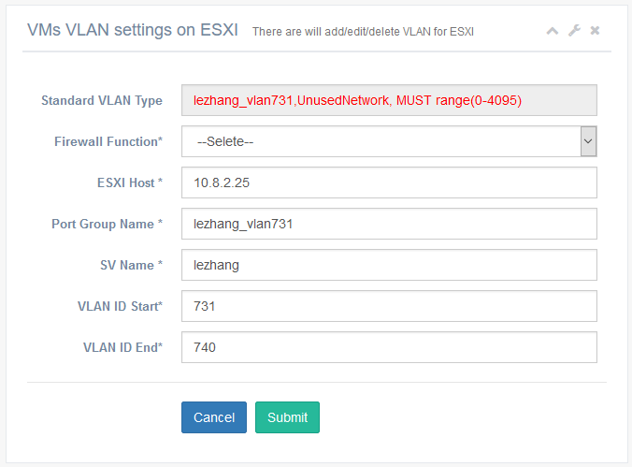
For Administrator, open the Sync All ESXI VMs button in that. It will sync all VMs info from ALL ESXI. Suitable for querying real-time for VM information.
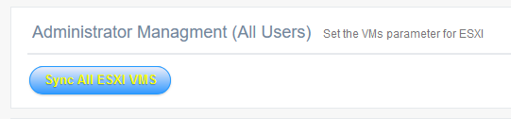

Ticket(Feedback)
Tickets use to record the various problems occurred in LAB/VLAB such as check/transfer/move FW or Switch. You can submit any problems occurred in the LAB/VLAB or problems requiring assistance from the administrator
* VLAB BUG Submit
* Firewall License request
* LAB Device check/transfer/move
* Else problem in LAB

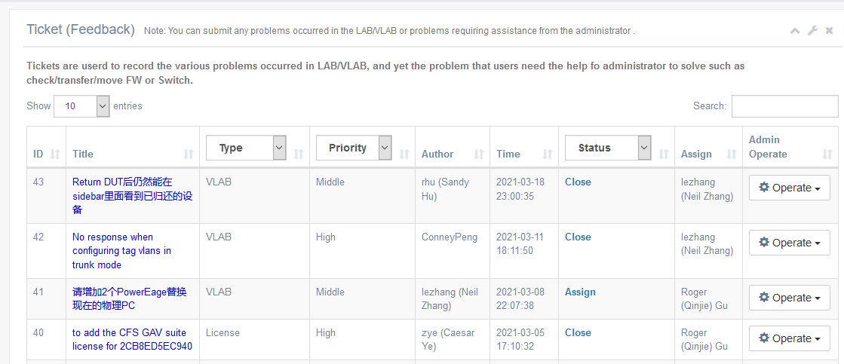

If you add a ticket, the administrator will receive a request email from VLAB. He will response your ticket in time. If not, please contact him at Teams.
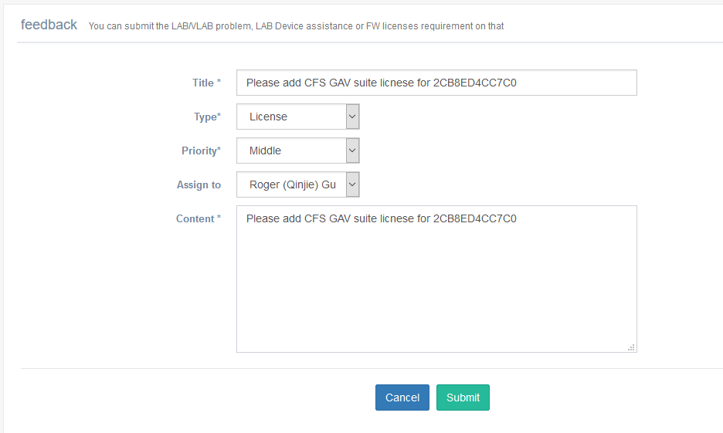

VLAB LOG

Long Tasks Log
Show All Long Tasks logs that are queued. Include: Sync All ESXI VMS, Borrow/return DUT
For Sync All ESXI VMS，it will print the process for all ESXI, end in SUCCESS.
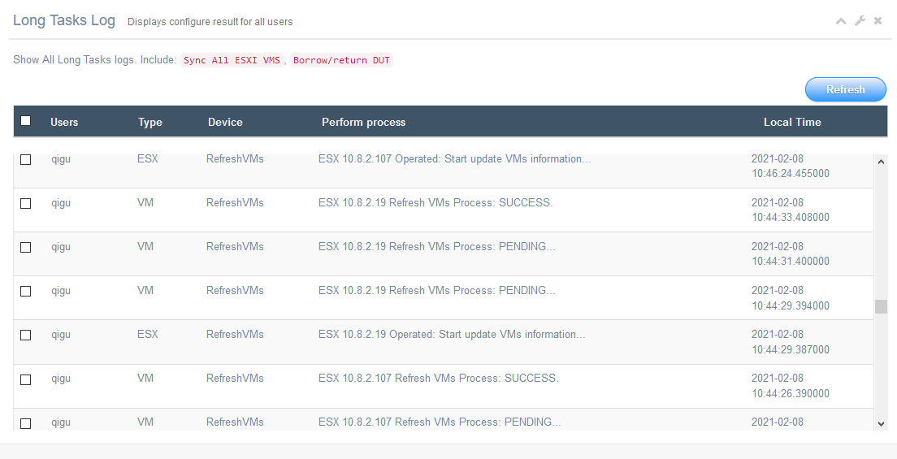
For Borrow/return DUT，it will print the process for the DUT, end in Finished Initial All Ports.
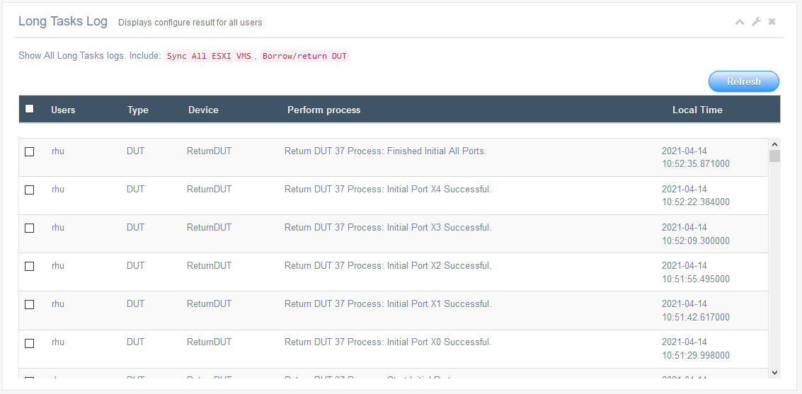

Login Log
In index page. Show all login Users information.
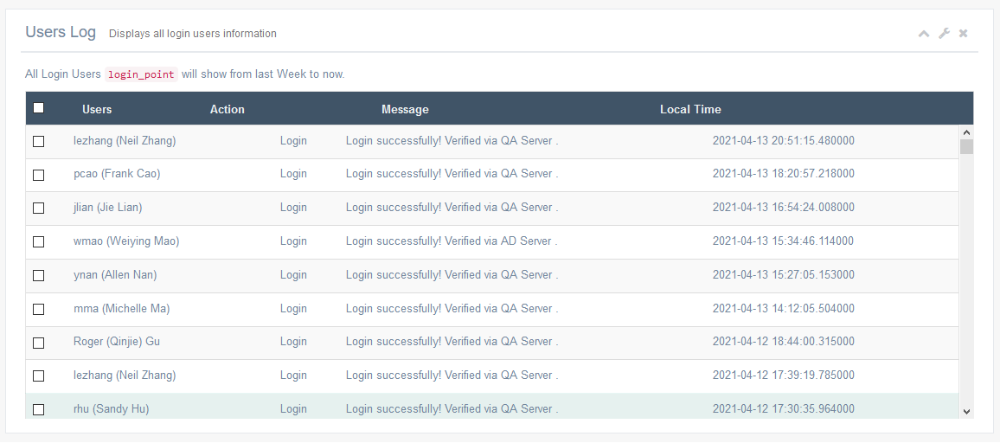

Operated Log
Show all configure log such as firewall/sonicpoint/vm/
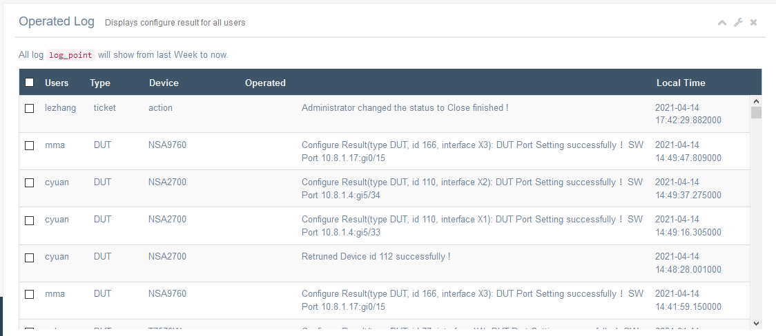

User Guidelines

Must to do (First Login)
Make sure you have access the VLAB for permission. If not, please contact the VLAB administrator first.
- Refresh DUT, VM and sync all VMs information in top menu
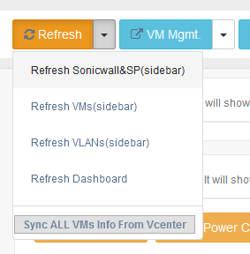

- Choose a Firewall on side menu,
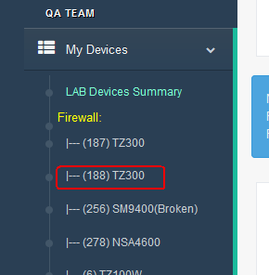
- Refresh ALL Interfaces while you first opened. (it will check data between switch Port with local DB)
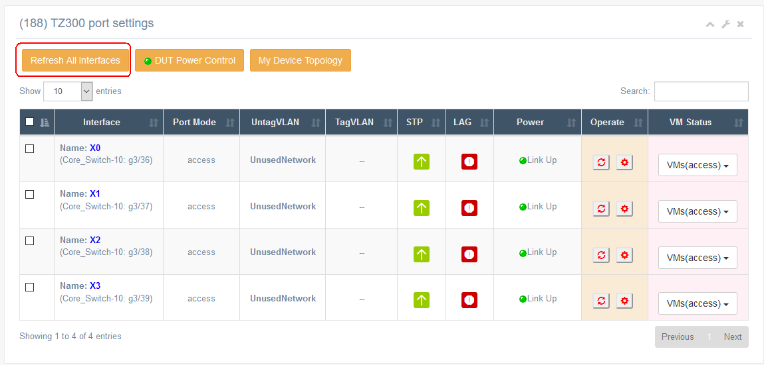
- If DUT Power is off, please power on first. Otherwise the DUT Port can not be operated.

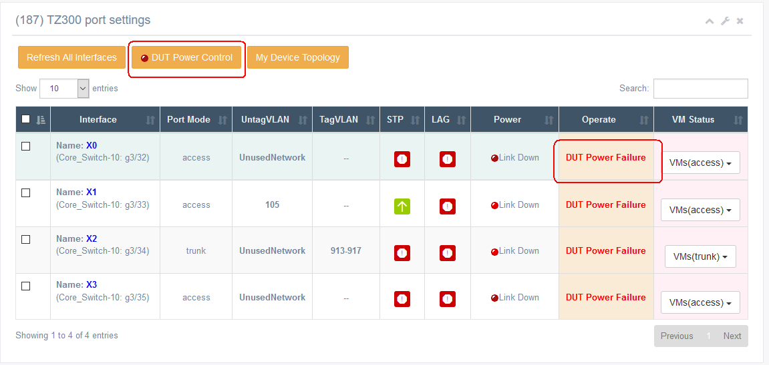

Borrow/Return DUT

- Click on “LAB Devices”
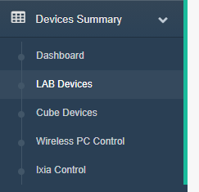
- Click on the “Borrow” button and Borrow the DUT. A remind email will send to device user.
Please first obtain the consent of the current user of the device !
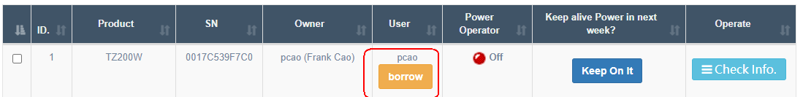
- Waiting for logs show ‘Finished Initial All Ports’, Check My Devices list, the borrow DUT will show in your devices list.
- Check ‘Return DUT’ to return, it will return the DUT to Owner. A remind email will send to device Owner
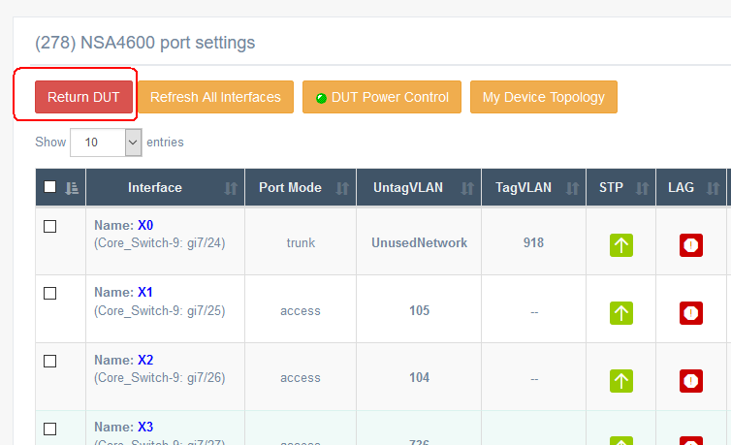
For Device Owner, also can get back the DUT in Lent Device list directly. A remind email will send to device user.
please make sure you have contact with curent user first.
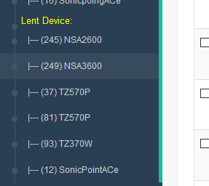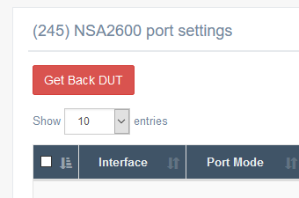

Firewall & SonicPoint port config
- 电源控制逻辑： 此处为非实时显示设备供电状态，当为Power Off时，表示设备断电中，无法进行任何接口配置，需要将设备上电后进行接口操作。
- Core Switch 配置逻辑： 只显示DB中存储的接口状态，配置前建议用Refresh SW 按钮同步一次Switch中的当前配置，然后再做操作。
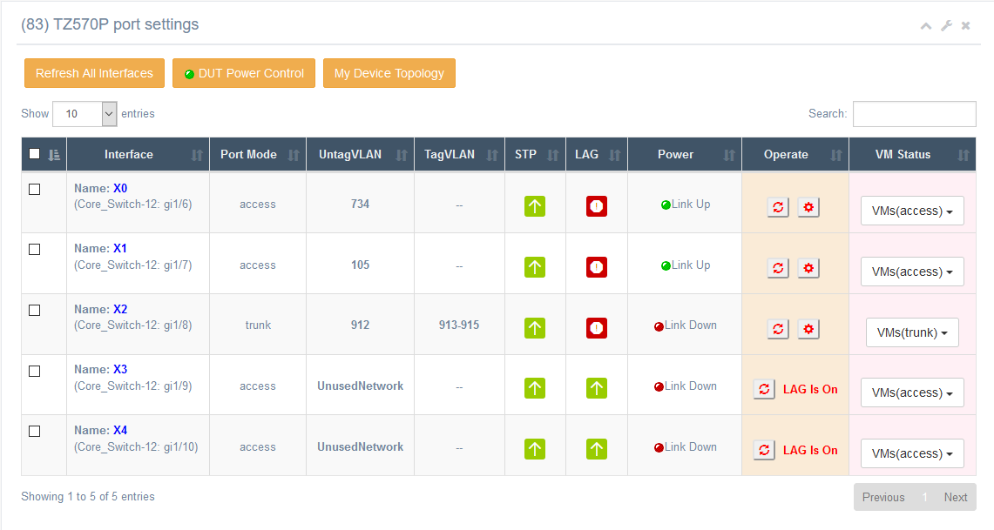
目前支持port mode，vlan，spannning tree，port Power配置，VMs VLAN 配置，LAG只支持状态检查；
Port Mode---支持access， trunk两类接口，不需区分交换机类型；
VLAN---支持配置Untag，Tag，不需区分交换机类型，统一使用如下规则：
当access时， Untag可配单VLAN，Tag配置无效（默认–）；
当trunk时， untag可配单VLAN（不能与tag重叠）， Tag自由定义，格式 734-735，736-739；
当不想让当前接口占用VLAN是，可将Untag配置成UnusedNetwork，此时会将接口自动配置成初始化状态，接口断电，VLAN置为1；
Spanning Tree—支持enable, disable, 不需区分交换机类型，默认为On；在测试L2 bridge， wire mode等多接口功能时使用；
LAG---可查交换机中是否被配置了LAG，如果是enable状态，无法做该接口的任何配置操作，请联系管理员对接口进行初始化；（暂时只支持查看功能, LAG的配置待开发）
VM list---显示与接口VLAN相同的所有Vcenter中的VM NIC，可通过Change VLAN去配置对应VLAN;
Port Status—有Link Up，Link Down两种状态，显示SW接口的电源状态，可用Disable/Enable按钮进行切换；
注意有一种情况是status显示Link Up, 但是devie接口仍然是no link状态，此问题较为复杂，可能是SW接口到device的连线松动，可能是接口间产生了回环触发了spanning Tree，也可能是device本身的配置问题或者软件BUG，此时请先自查，无法定位问题时请联系管理员排查。

- Borrow/Return Wireless PC
借用Wireless PC，请在wireless PC Control页面或者PC Mgmt里进行操作，有release和occupy两种操作，占用后会有携带PC随机密码的mail发送给占用者，请RDP时使用，用完请及时release.
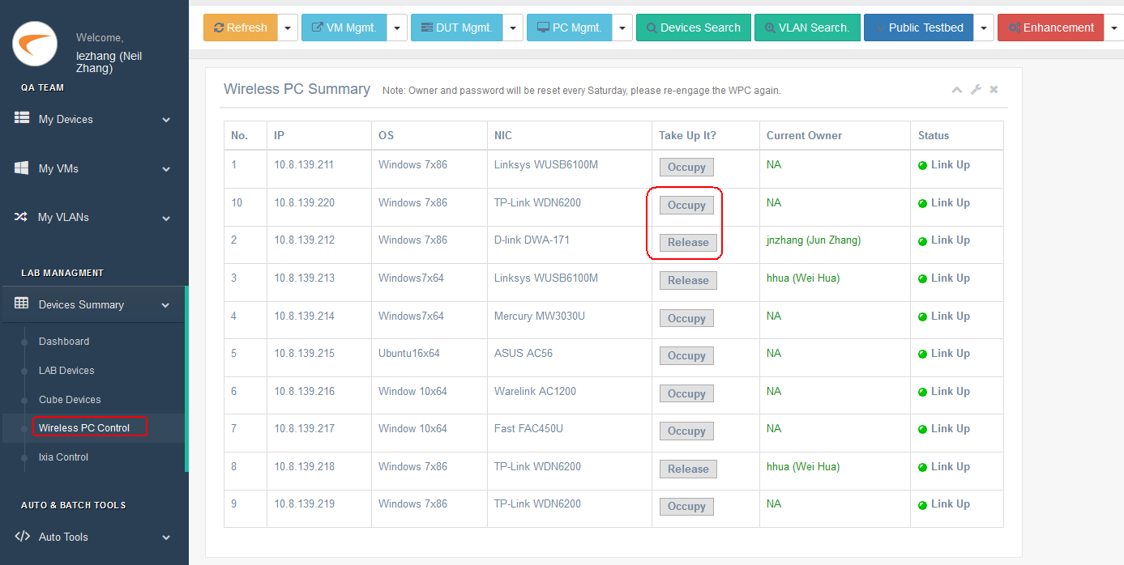
- Borrow/Return IXIA
借用IXIA，请在Ixia Control页面或者PC Mgmt里进行操作，有release和occupy两种操作，Ixia VM 请RDP使用，通用密码qa/password，用完请及时release.
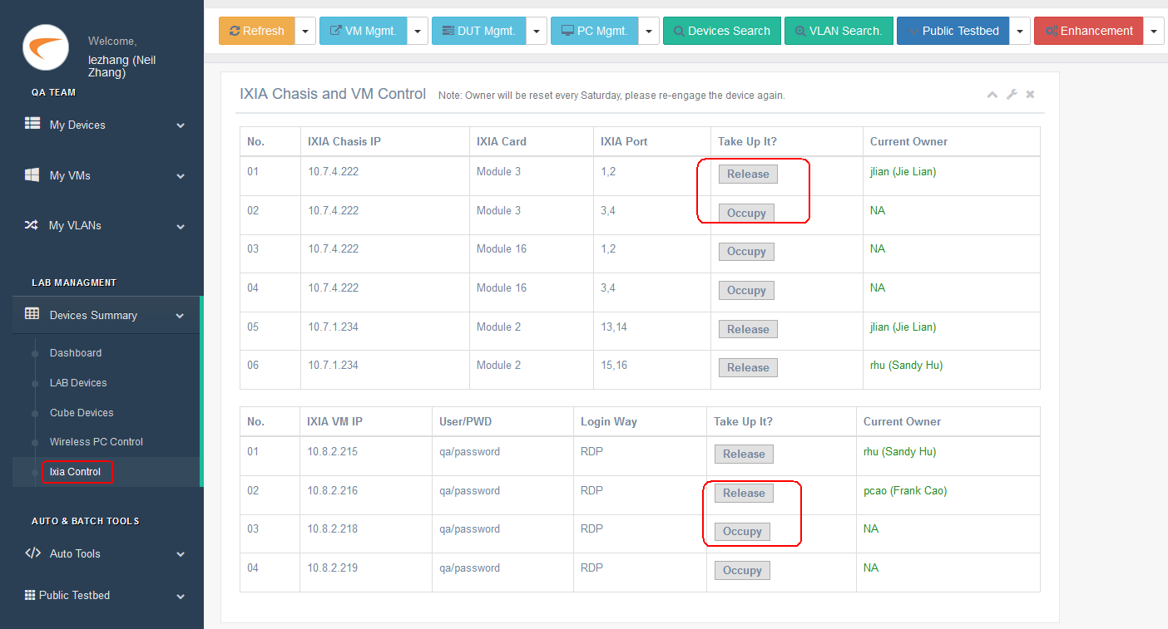

Tips & Debug

Err-disabled.
When a loop occurs between the switch ports, the STP will trigger the port down. If you’re sure you’ve built the right network for testing, please turnoff the STP in ports and reboot it. The port will be forced to no shutdown.
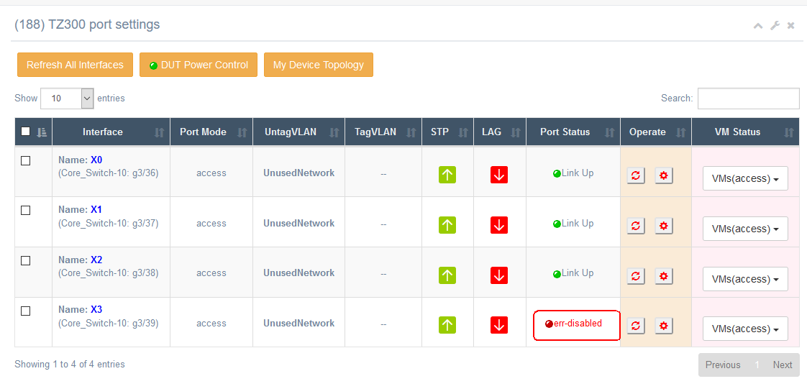

DUT Power Failure.
When the DUT is not powered on, nothing can be configured for the SW port.
Please Power On it use DUT Power Control button
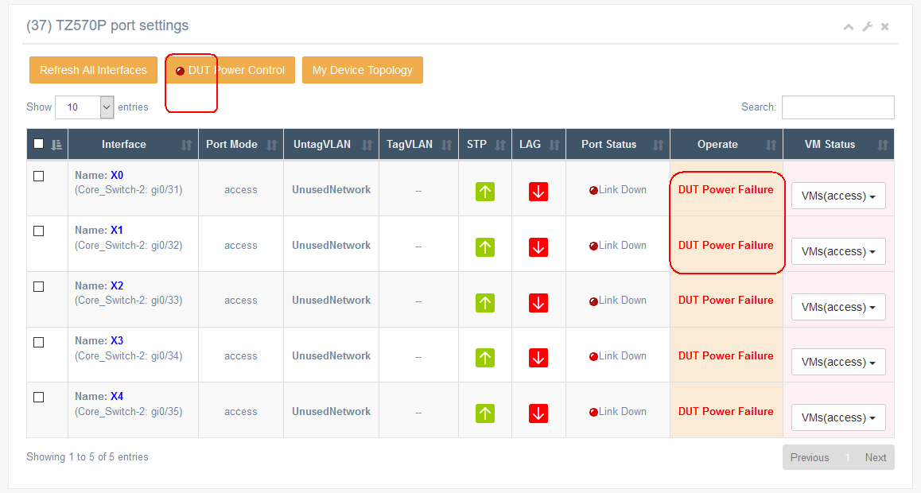

LAG On.
When the LAG is on in Switch port, the DUT port only can be refreshed. Please contact LAB administrator to unbundling it and refresh it again.

Pre-configured Failed.
When the Flash show the pre-configured failed, the reason is that the pre-configuration of SW port does not meet the configuration requirement of VLAB. You can initial it in Reset Setting page. If there’s still a problem, Please contact LAB administrator.
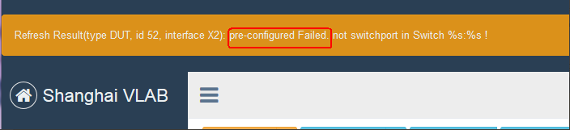
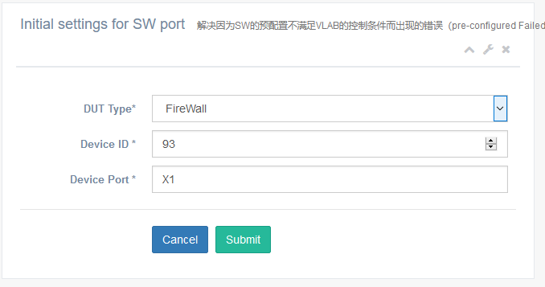

Transfer Public Pool.
When you want to share a DUT with other team members, you can ask LAB administrator to transfer to Public Pool, in that all user can config it. Please consult with relevant personnel on how to use it.
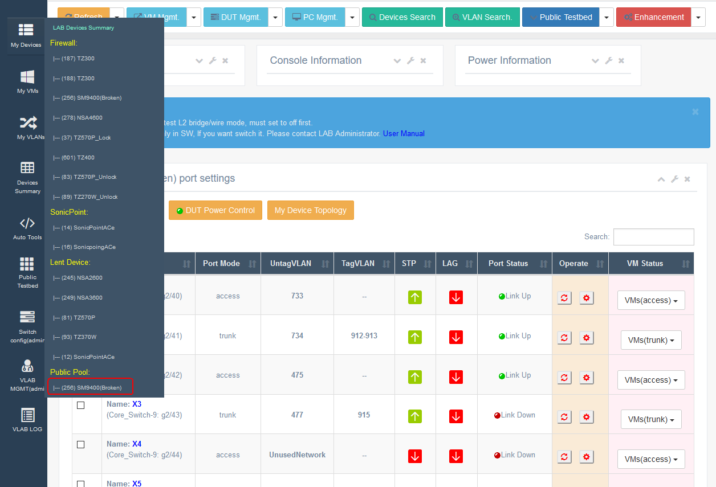

Response error.
Sometime when you go into a device page and configure an interface immediately (use configure button), the current page will response a data error. The reason is that the page load data is incomplete, if you submit them, the response will shou a type error.
Resolved: Please wait for few seconds and then press configure button.
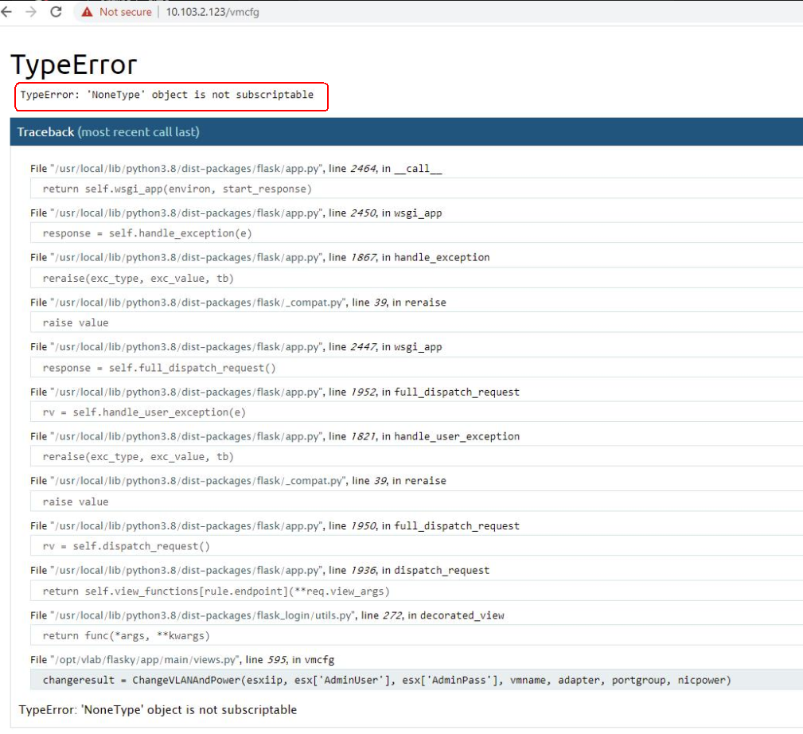

Switch line protocol down.
Sometime when you’re config the device port all with show the link down. Please check the line protocol status in console log. If it’s down, it’s data link error, such as clock out of sync/duplex model is different/inconsistent interface rates, please contact LAB administrator to debug.
